Asynchronous Actions
Asynchronous actions are a means by which an application can request that a provider do work, but in such a way that the application can carry on other operations while the provider does that work. This is possible because asynchronous actions, once executed, will fire as an asynchronous callback event once the operation is completed. Through this event, the provider informs the application of the result of the action.

You should always use an asynchronous action over synchronous provider or native actions if your action has the potential to take a long amount of time (say, even over a second). For instance, if you are communicating over sockets, doing File IO, or any operation in which circumstances out of your control can cause the action to take a bit of time, then you should always use an asynchronous provider action.

Asynchronous Action Flow
To demonstrate how an application executes an asynchronous action, consider the Play async action in the MediaControl library.

When one drags the Play action to a function canvas in the Application Designer, one sees the following figure:

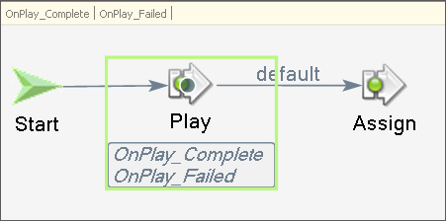
Figure 1: The Play action as an example of an asynchronous action

There are two important visual elements to consider:
- The Play action itself.
- The OnPlay_Complete and OnPlay_Failed function event tabs (top-left).

Recall that when you use the Play action, or any asynchronous action, you are simply asking the corresponding provider to go do work for you—but the script does not wait in that function for the final result of that asynchronous action. That is why there are the Complete/Failed event tabs—to asynchronously indicate back to the script the final result of the action.

The following sections describe in detail how asynchronous actions execute.

Step 1: Action is executed by Application Runtime
When the runtime reaches an asynchronous action, a message is created. The contents of that message are based on the values for each action parameter as specified in the property grid, and then sent down to the corresponding provider to be processed. The provider will have a callback automatically invoked for this action invocation in the script. The callback that is invoked is specified in the messageCallbacks HashTable in the provider.

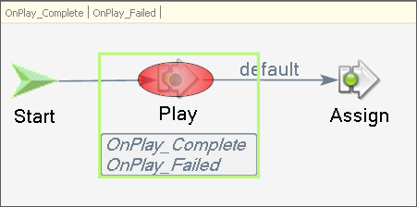
Figure 2: Asynchronous Provider action is reached by the runtime

Step 2: Continuation Due to Provisional Response from Provider
Once the provider responds with a provisional response to the application, the script continues executing to the next action. In plain English, one can interpret a provisional response as the provider saying to the application script, “Hey, I got your message, and I’m going to go work on it for a while (or not work on it, in case of a failure provisional response)”.

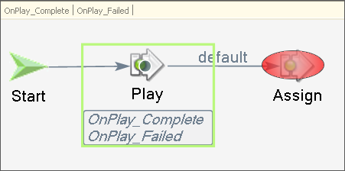
Figure 3: Script carries on to the next action after a provisional response

Step 3: Final Response from Provider--Asynchronous Callback Event
Once the provider has fully completed the action request from the script, the provider must respond back to the script with an asynchronous callback event, to let the script know that the work is done.

This asynchronous event corresponds to a different event handler, or function, being executed. In the Application Designer, the script logic of the function is housed in a function tab.

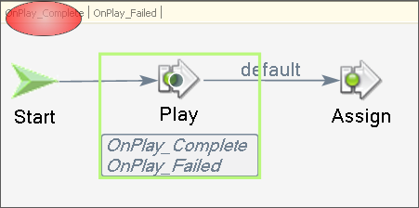
Figure 4: Once the asynchronous callback event is received by the application, a different function begins executing

Putting it Together--The Provider Code
The TelnetProvider SDK example provider already defines a simple synchronous provider action. This example will take that provider’s class file and modify it to make an example asynchronous action—the Write action. The Write action sends a string to a client socket.

Please refer to the ProviderTemplate.cs provided with this document for the walk-through provided here.

Step 1: Declaring the Action Asynchronous
One must declare in the Action attribute that the action is asynchronous. This can be done by setting the last parameter to true done with this particular overload of the Action attribute as follows:

[Action(ProviderNamespace + "." + "Write", false, "Write", "Writes to the telnet session", true /* IS ASYNC?? */)]
// removed code
protected void WriteMessageHandler(ActionBase action)
{
Figure 5: Asynchronous Action Attribute

Step 2: Declaring Asynchronous Callback Events
The asynchronous callback events associated with your asynchronous action must be formally declared in your provider for every asynchronous action. To do so, use an Event attribute on a dummy method—one dummy method for both the Complete and Failed event callbacks as the following code illustrates:

[Event(ProviderNamespace + "." + "Write", true)] // Tell pgen.exe what action are we qualifying
[EventParam("Duration", typeof(int), true, "The amount of time (ms) for how long the write took")] // declare any event params
private void _WriteSuccess() {} // Name of method is arbitrary... choose whatever you like

[Event(ProviderNamespace + "." + "Write", false)] // Tell pgen.exe what action are we qualifying
[EventParam("ErrorMessage", typeof(string), true, "The message associated with an exception thrown on write attempt")] // declare any event params
private void _WriteFailure() {} // Name of method is arbitrary... choose whatever you like

Figure 6: Asynchronous Callback Event Declarations

The reason you have to declare bogus methods is due to the inherent architecture of .NET attributes. Attributes have to decorate something, whether that something be fields, properties, or methods. So by convention, pgen.exe will look through each method and check to see if it has been decorated with the Event attribute. It will then match any asynchronous callback event declarations with the action itself when the package XML file is generated.

Notice that when declaring asynchronous callbacks, you have the opportunity to say which event parameters, if any, are associated with the Complete and Failed callbacks. Recall that event parameters are the facility by which providers pass up additional fields of information along with an event to tell the script more about the event than just, “an event happened”. So you have the opportunity to pass distinct fields of data for either the Complete or Failed callbacks.

Step 3: The Right Way to Code an Asynchronous Action
One extremely important aspect of providers to understand there is a single thread processing all actions requests inbound from applications. Specifically, this means then that your provider must spend the least amount of time as possible in the callback functions defined in your messageCallbacks HashTable.

Due to this behavior, you should always put the actual work for an asynchronous action in its own thread, so that the provider message queue is not blocked processing a particular action. Consider the implementation of the Write action:

protected void WriteMessageHandler(ActionBase action)
{
string message = null;
int socketId = -1;

action.InnerMessage.GetString("Message", true, String.Empty, out message);
action.InnerMessage.GetInt32("SocketId", true, -1, out socketId);

action.SendResponse(true);

pool.PostRequest(writeSocket, new object[] { action as AsyncAction, message, socketId });
}
Figure 7: Asynchronous Callback Event Declarations

The WriteMessageHandler method is defined as the callback for the Write action. This method does 3 significant operations:
- Extracts action parameters from the incoming action message (action.InnerMessage.Get*)
- Sends a provisional response to the script (action.SendResponse(true)).
- Uses a thread pool to ask for the real work to be done. This real work is the actual writing to the socket (a potentially time-intensive operation!), and so proper coding demands that we relinquish the thread processing our WriteMessageHandler, in order that the provider message pump can pop the next message off the provider message queue.

Step 4: Once Done with the Work, Send the Asynchronous Callback Event
Once your provider is done processing the action in its entirety, it is up to you the provider developer to send the final asynchronous callback event back up to the script, to let it know that the action is completed.

Consider the following method, which the WriteMessageHandler asked the thread pool to execute (the last line from Figure 7):

private void WriteOutToSocket(AsyncAction action, string message, int socketId)
{
bool writeSuccess;
DateTime start = DateTime.Now;
TimeSpan duration = TimeSpan.Zero;
string errorMessage = String.Empty;
try
{
server.Write(socketId, message); // write to the socket

duration = DateTime.Now.Subtract(start);
writeSuccess = true; // the write succeeded
}
catch(Exception e)
{
errorMessage = e.Message; // save why the write failed
writeSuccess = false; // the write failed
}

EventMessage asyncEventMessage = action.CreateAsyncCallback(writeSuccess);

if(writeSuccess)
{
asyncEventMessage.AddField("Duration", duration.TotalMilliseconds);
}
else
{
asyncEventMessage.AddField("ErrorMessage", errorMessage);
}

palWriter.PostMessage(asyncEventMessage);
}
Figure 8: Doing the work and then sending the asynchronous callback

The code in Figure 8 does 3 significant operations:
- Performs the real work of the action (server.Write(socketId, message)).
- Constructs the asynchronous callback event message. (EventMessage asynchEventMessage = action.CreateAsyncCallback(writeSuccess)).
- Sends the event message, with fields, back to the script. (palWriter.PostMessage(asyncEventMessage)).

In Conclusion
Asynchronous actions are straightforward to write, as long as you follow a few simple rules. Most important, keep the provide message queue thread open and available to processing action requests from scripts, by putting the potentially long-running operations of your asynchronous actions on their own threads. Secondly, make sure you do not forget to send your provisional response, as well as the final asynchronous callback. Asynchronous callbacks are implicitly guaranteed—so please make every effort to make that a reality in your provider. The one exception to this rule is if you send a provisional failure response to the script. In that case, the provider is telling the script that the action request was received, but it could not be processed, so no asynchronous callback events should be fired.

The ProviderTemplate.cs file provided with this example can be copied over the ProviderTemplate.cs file of the TelnetProvider project provided on the SDK CD for building. The ProviderTemplate.cs file also has a fair amount of commenting, not shown in this document.

